Bug Report - 05:

Mini Statement text is not fully translated to Hindi
Environment: Windows 11, Opera GX
Test Object: Language Translation / Mini Statement

Preconditions:
- The website is open
- The user is logged in
- The user has completed at least one transaction (e.g., a deposit)

Steps:
- Scroll down and click the Hindi language button
- Verify the ATM interface changes to Hindi
- Click on 'Mini Statement'

Expected Result:
- All text inside the Mini Statement, including transaction labels like 'Deposit', should be translated to Hindi

Actual Result:
- The transaction labels (e.g., 'Deposit') remain hardcoded in English inside the statement list
Attachment:
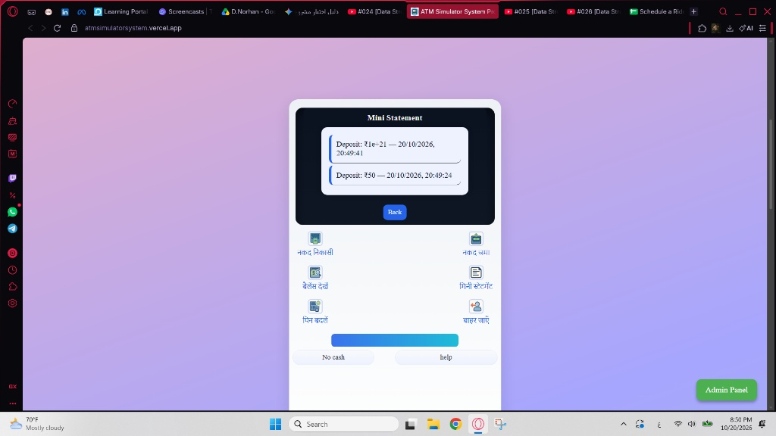
Severity: Low
Priority: Low

